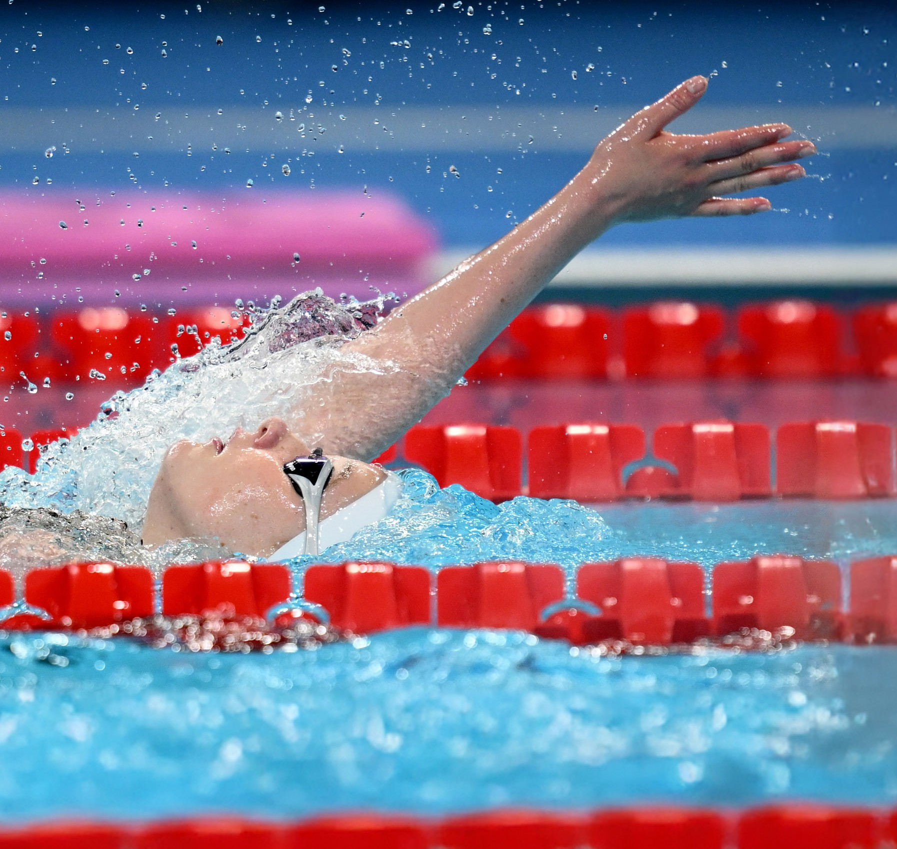

**EN HYLDEST TIL**

PARASVØMNINGENS FORBUNDSMESTER 2024

& DIF DANMARKSMESTER 2024

**DIF DANMARKSMESTER 2024**

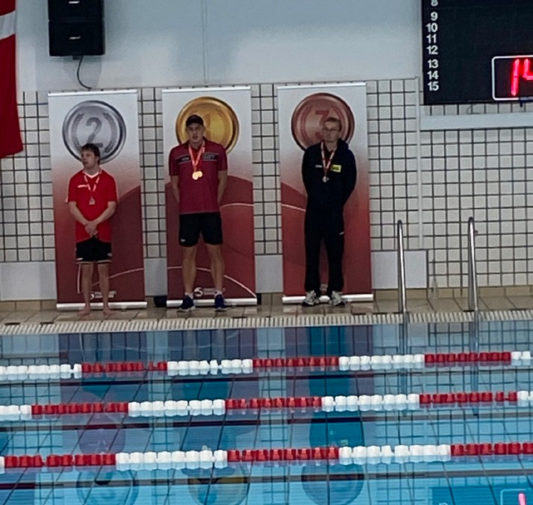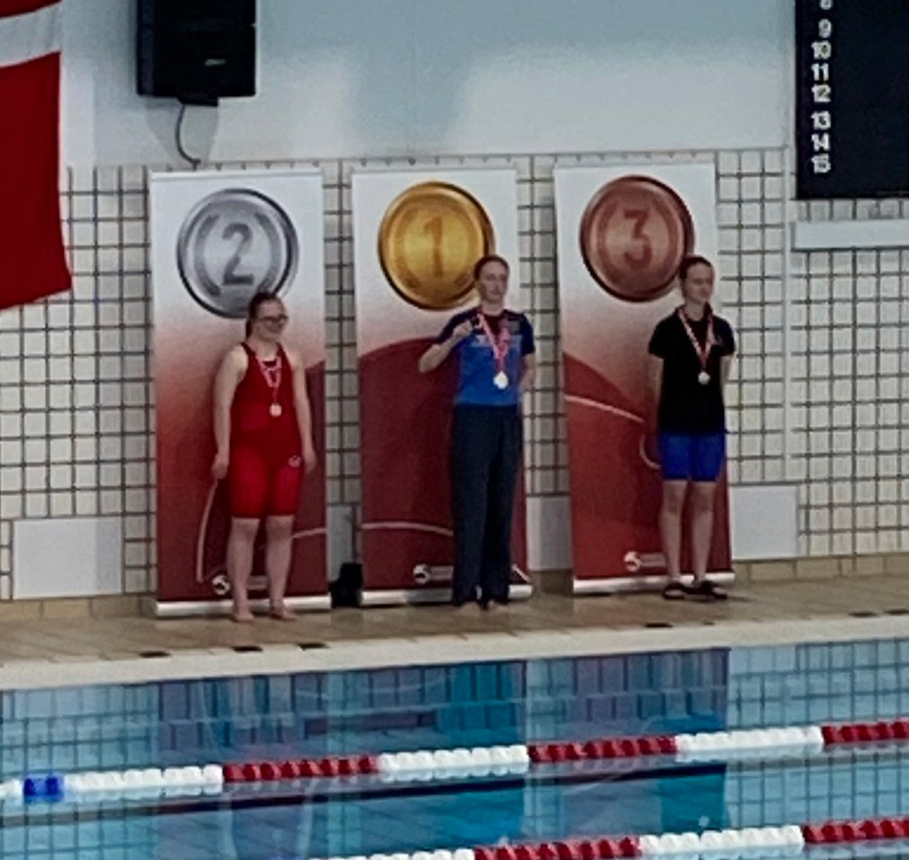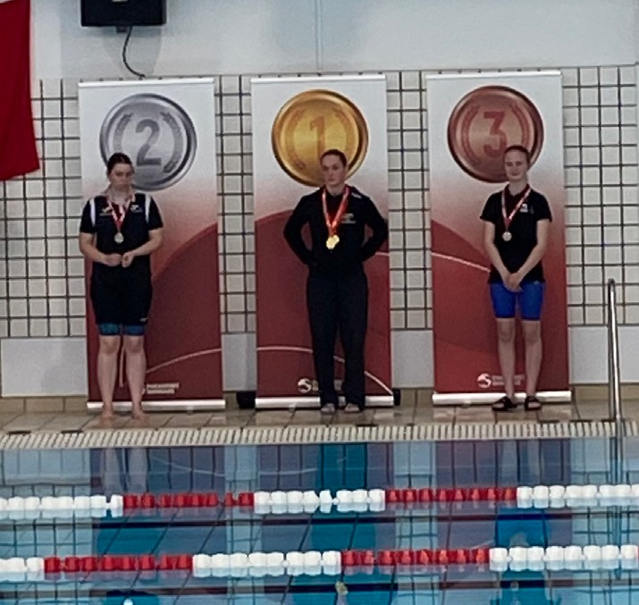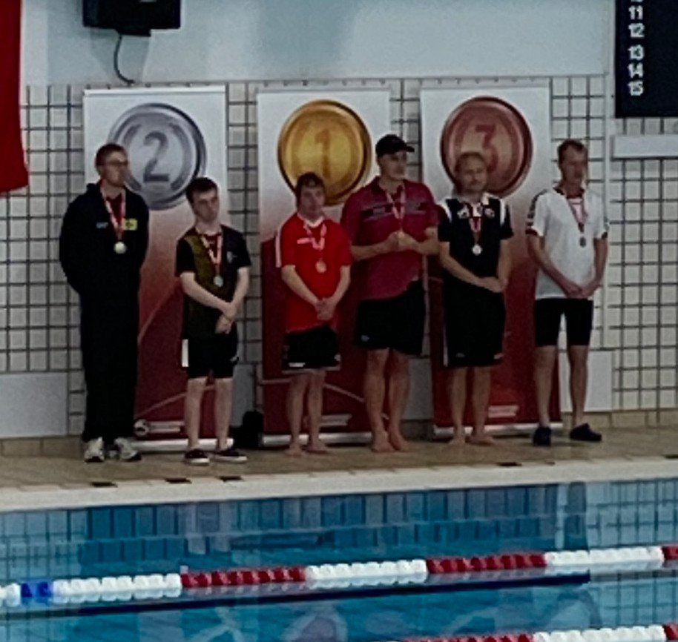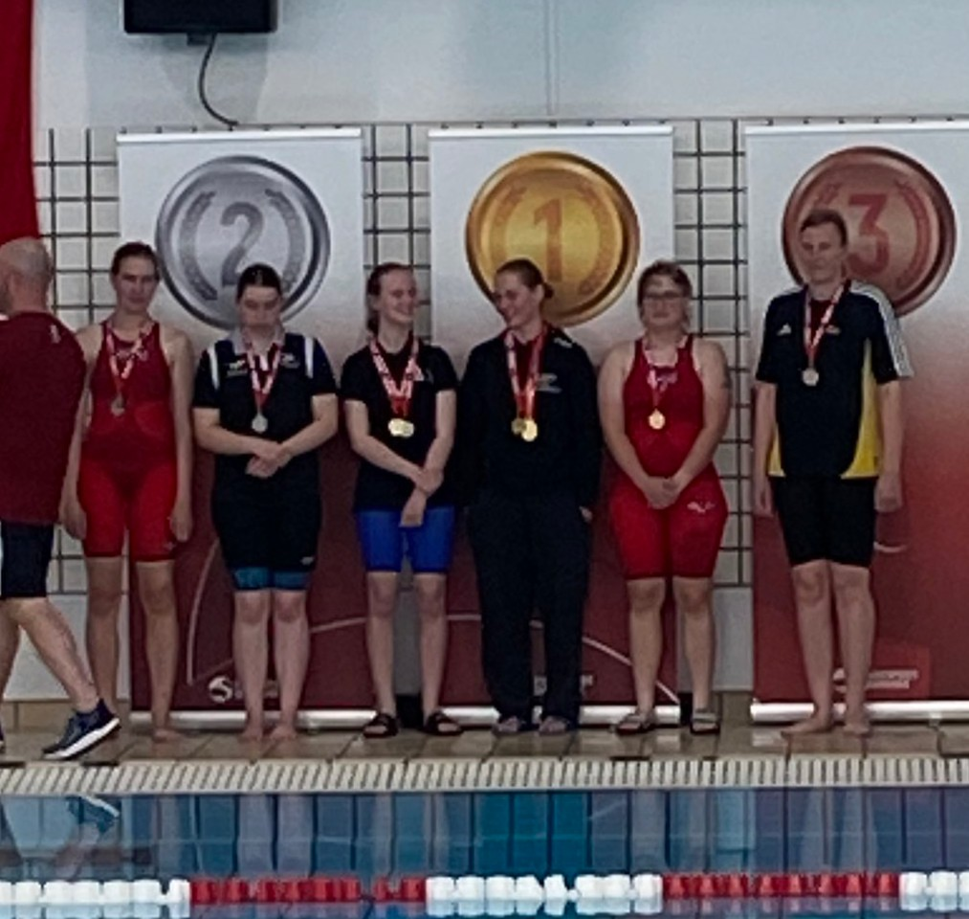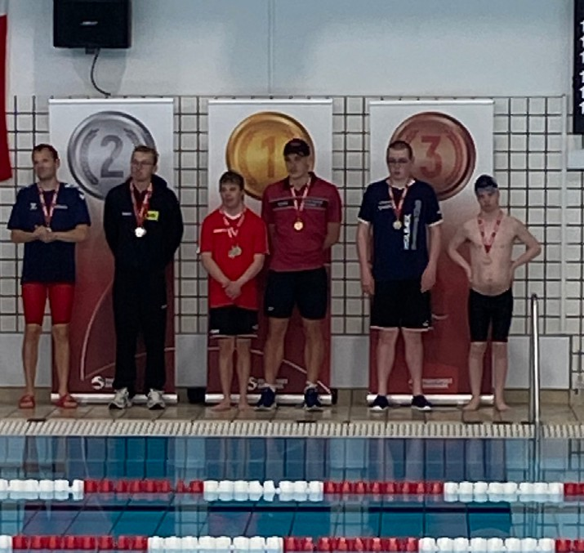

|  |  |  |
| --- | --- | --- |
| Løb | Damer | Herrer |
| 50 ryg | Johanne Øland Frøkjær | Frederik Valentin Knudsen |
| 100 ryg | Johanne Øland Frøkjær | Alexander Hillhouse |
| 50 bryst | Freja Kvist | Christian Bundgaard |
| 50 fri | Johanne Øland Frøkjær | Nis Heide Pinnerup |
| 100 fri | Maria Kjer Rasmussen | Nis Heide Pinnerup |
| 200 fri | Maria Kjer Rasmussen | Alexander Hillhouse |

**FORBUNDSMESTER 2024**

|  |  |  |  |
| --- | --- | --- | --- |
|  | *Børn/Årgang S1-S14, S18 & S19* | | *Junior/Senior S1-S14, S18 & S19* |
| Løb | Damer | Damer | Herrer |
| 50 fri | Madeleine Højer Ringgaard | Freja Kvist | Anders Bjørn Rasmussen |
| 100 fri | Madeleine Højer Ringgaard | Maria Kjer Rasmussen | Marius Danielsen |
| 200 fri | Saga Høgh | Maria Kjer Rasmussen | Alexander Hillhouse |
| 400 fri | Asta Sejr Hansen |  | Frederik Schmidt Johansen |
| 50 ryg | Madeleine Højer Ringgaard | Sofie Langballe Andersen | Jonas Rose |
| 100 ryg | Johanne Øland Frøkjær | Sofie Langballe Andersen | Alexander Hillhouse |
| 50 bryst | Saga Høgh | Freja Kvist | Anders Bjørn Rasmussen |
| 100 bryst |  | Freja Kvist | Frederik Schmidt Johansen |
| 50 fly | Asta Sejr Hansen | Isabella Pillov | Alexander Hillhouse |
| 100 fly | Asta Sejr Hansen |  | Marius Andersen |
| 200 Medley |  | Madeline Skovhus | Frederik Schmidt Johansen |

|  |  |  |
| --- | --- | --- |
| *Masters S1-S14, S18 & S19* | | |
| Løb | Damer | Herrer |
| 50 fri | Eva Rosted | Niklas Jacobsen |
| 100 fri | Eva Rosted | Nis Heide Pinnerup |
| 200 fri | Michele Nybo Larsen | Nis Heide Pinnerup |
| 400 fri | Michele Nybo Larsen |  |
| 50 ryg | Eva Rosted | Nis Heide Pinnerup |
| 100 ryg | Eva Rosted | Nis Heide Pinnerup |
| 50 bryst | Camilla Hansen | Michael F. Mortensen |
| 100 bryst | Camilla Hansen | Oliver Roug Nielsen |
| 50 fly |  | Michael F. Mortensen |
| 100 fly | Michele Nybo Larsen | Nis Heide Pinnerup |
| 200 Medley | Marie Husfeldt Hendriksen |  |

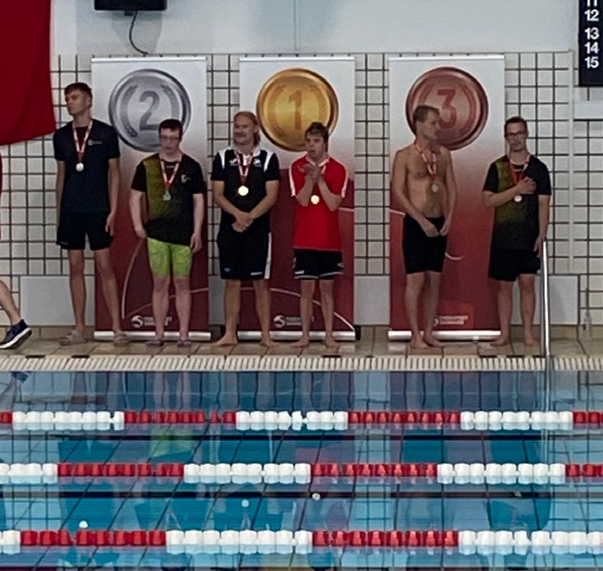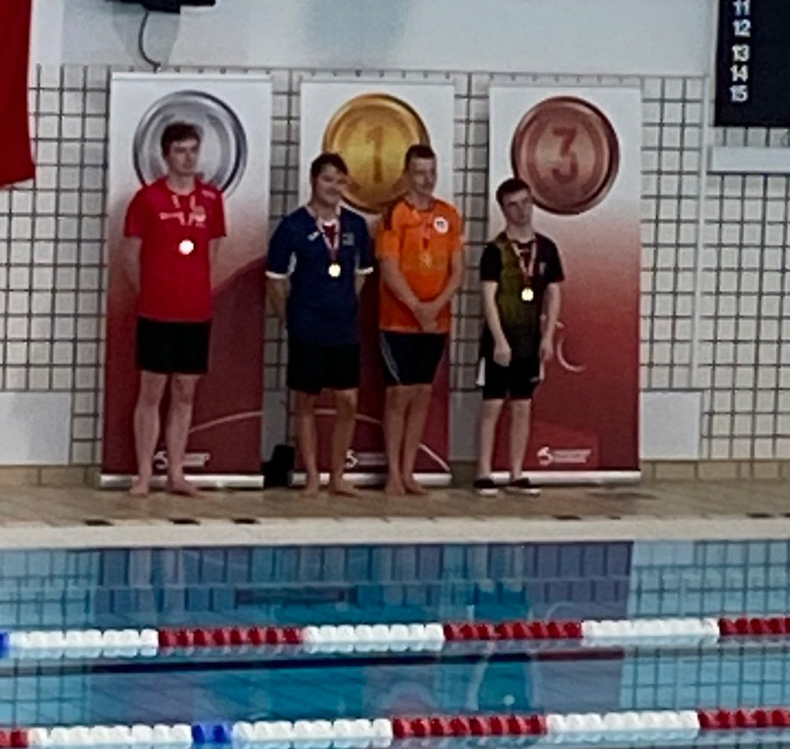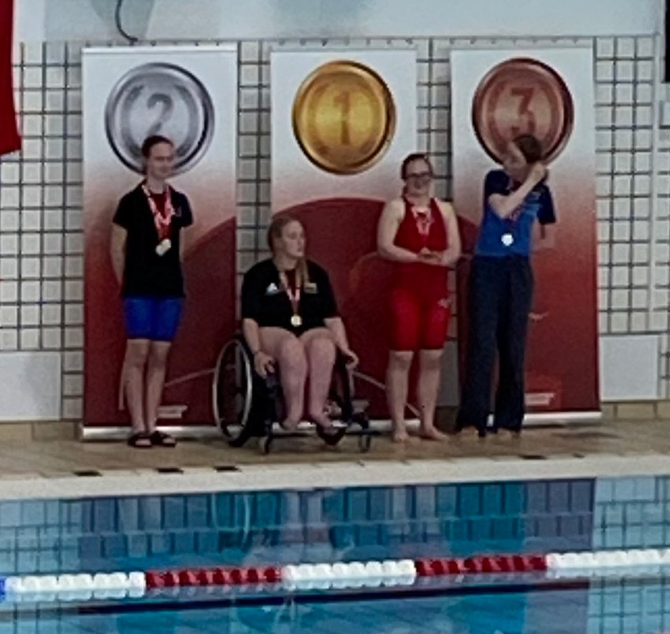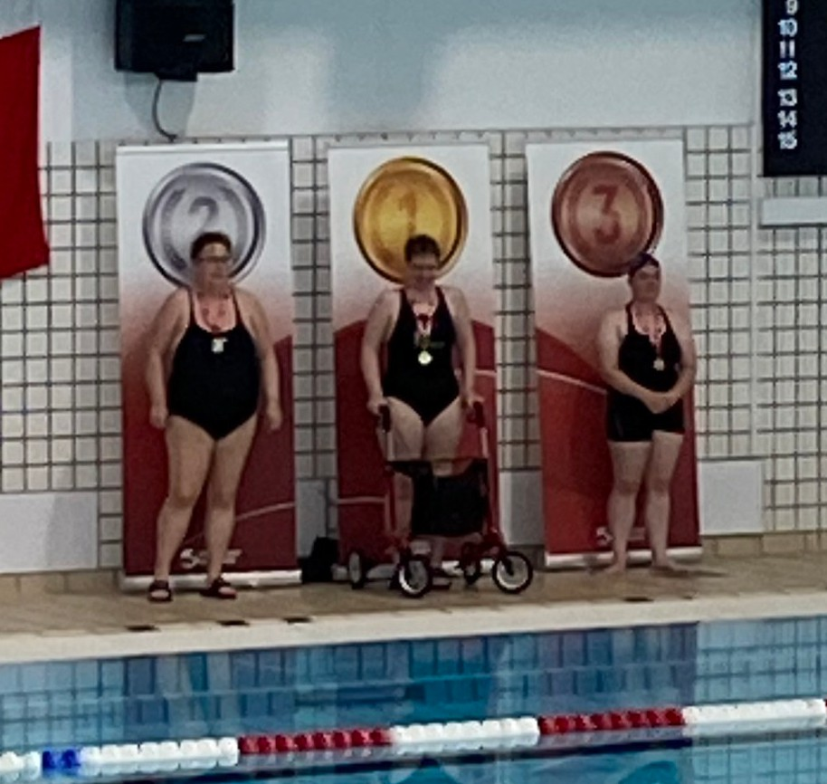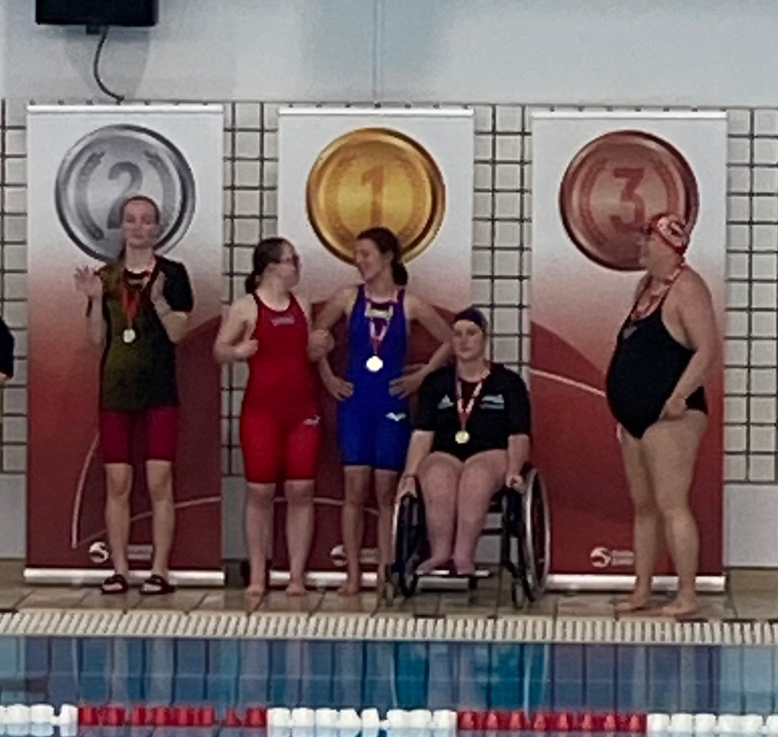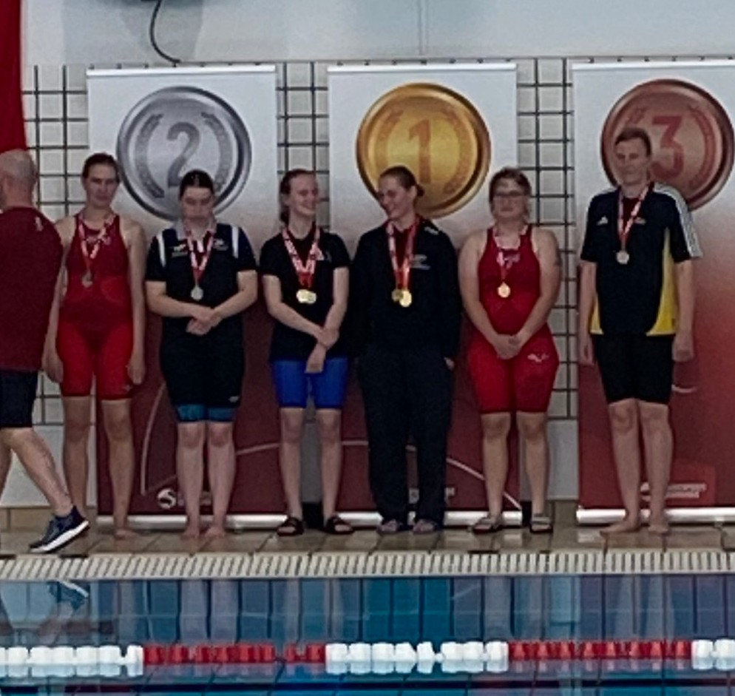

|  |  |  |  |
| --- | --- | --- | --- |
|  | *Junior/Senior - Åben klasse S17* | | *Masters - Åben klasse S17* |
| Løb | Herrer | Damer | Herrer |
| 50 fri | Magnus Hansen | Louise Pedersen | Martin Frederiksen |
| 100 fri | Magnus Hansen | Louise Pedersen |  |
| 200 fri |  | Louise Pedersen |  |
| 400 fri |  |  |  |
| 50 ryg | Kasper Bang Kaufmann | Louise Pedersen |  |
| 100 ryg |  | Louise Pedersen |  |
| 50 bryst | Nikolaj Eriksen | Anni Andreasen | Martin Frederiksen |
| 100 bryst | Nikolaj Eriksen | Louise Pedersen |  |
| 50 fly |  |  | Martin Frederiksen |
| 100 fly |  |  |  |
| 200 Medley |  |  | Martin Frederiksen |